The Last Outpost 2024 Alumni Appreciation Event
@
Engine 58 & Battalion 5
Retirements, 20 & 30 Years, Rotations & Transfers
5/31/2024
2pm - ???

Retirements – BC Bill McPeak, FF Mark Stewart
20 & 30 Years of Service – FF Bobby Davis, FF Brian Nevrincean, FF Bill Gillon, BC Al Tropiano, Capt Jimmy Stinson
Rotations & Transfers – BC Al Tropiano, BC Joe Doherty, Capt Jimmy Stinson, Lt Joe Fyke, FF Eric Siegfried, FF Felicia Iannella, FF Andrew Cardona, FF Joe Armbruster, FF Bill Gillon, FF Bobby Davis, FF Mike Polek
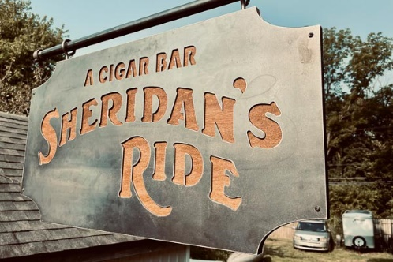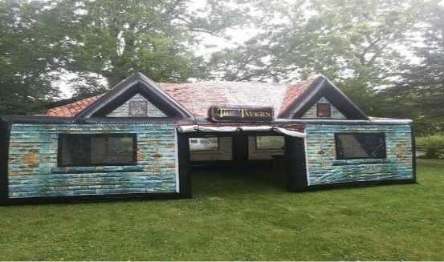
*Cigar Lounge – by Sheridan’s Ride Mobile Cigar Bar*
*Inflatable Pub – by TMD Entertainment*

- Open invite with food and drinks, any questions call Jason Miles E58D 267-718-5093
