PFD 179
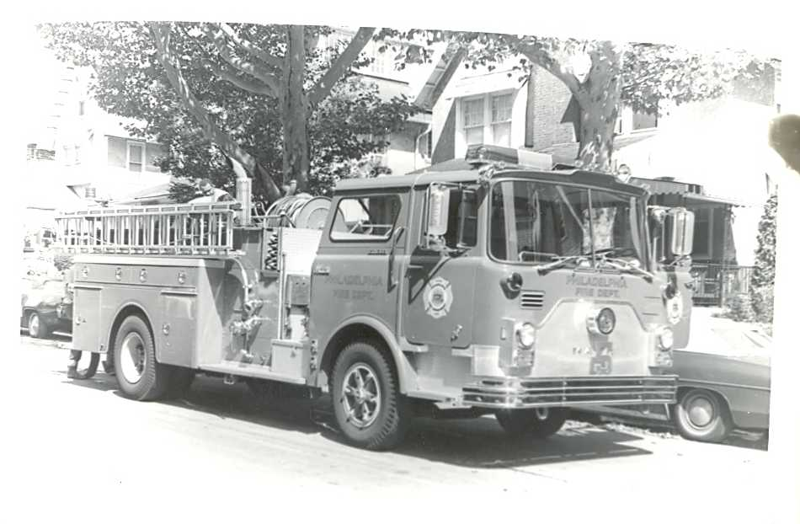
15 YEAR CLASS PARTY

WHEN: January 25, 2020 D/C

WHERE: Brick House Bar and Grill

3334 Grant Ave.
TIME: 7 till ?
CASH BAR!

