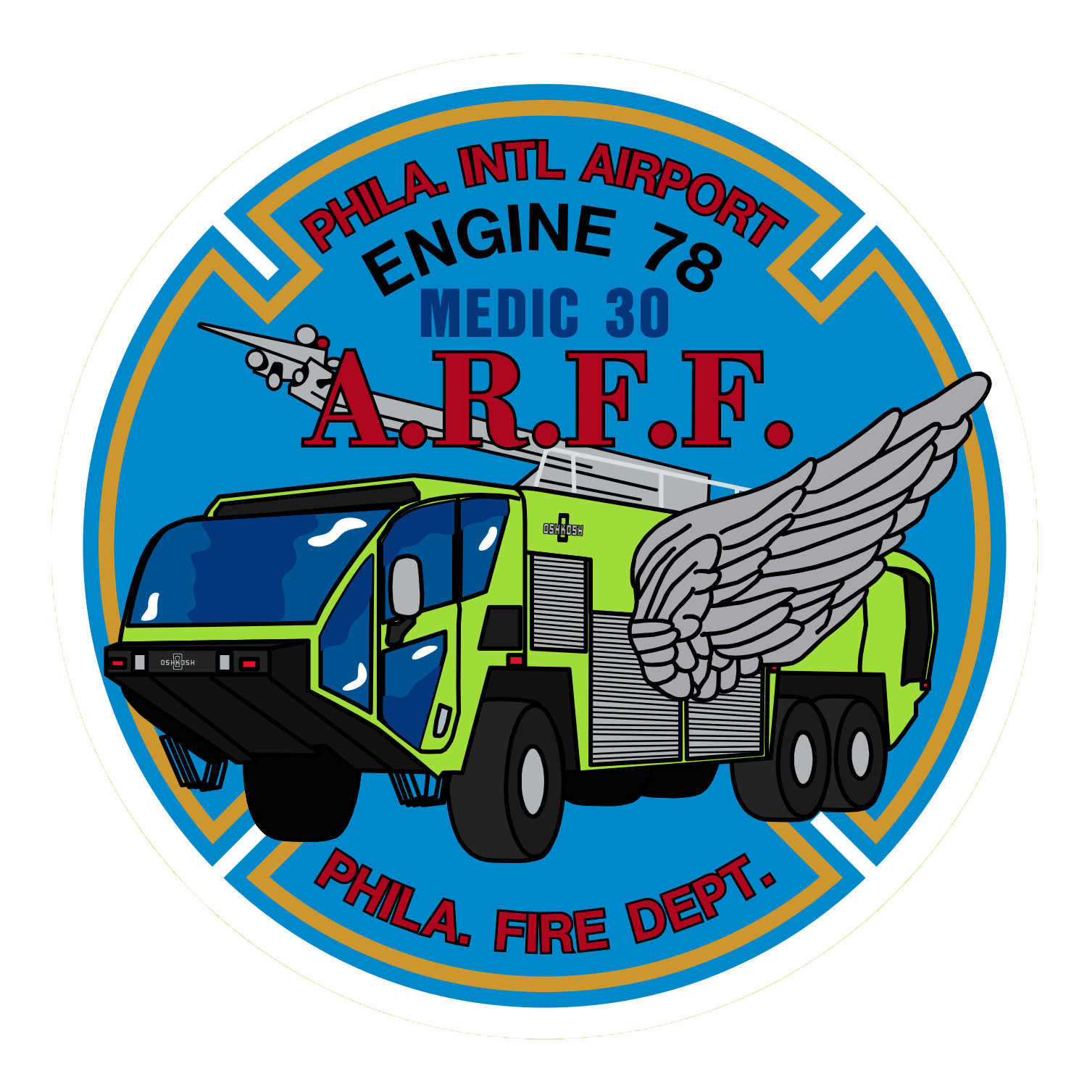
From The Members of Engine 78

We would like to express our heartfelt feelings
on the 1st Anniversary of the passing of Lt. Michael Bernstein
which is March 19, 2020.

The members were planning to have a formal ceremony,
however in light of the Covid 19 Pandemic this will have to be
postponed to a later date. The members of Engine 78 will be
having a private candle lighting and moment of prayer we ask
that all stations keep the Members of E78 and the Bernstein
family in pray

Sincerely the Members Of Engine 78

