PHILADELPHIA FIRE
OFFICERS ASSOCIATION
2500 Lefevre Street * Philadelphia, PA 19137

Professional Development Speaker Series:
March 19, ^{TH} 2025 D/C, 7:00PM

At this month’s meeting, Retired Fire Deputy Chief Vincent Mulray will review the events of the 2015 Amtrak Train #188 Derailment and Crash at Frankford Junction.
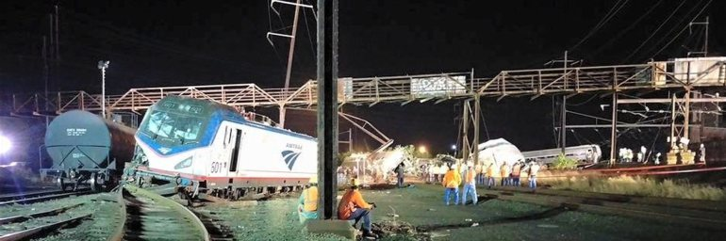

This presentation will follow and outline the Fire Engineering Magazine article from the October 2015 edition. Link to the article. Amtrak Derailment Operations: the First 24 Minutes - Fire Engineering: Firefighter Training and Fire Service News, Rescue
This presentation will outline the fire department response and operations to the Amtrak 188 derailment and crash through the eyes of the initial incident commander for the first 24 minutes and beyond. The presentation will follow my article published in the October 2015 edition of Fire Engineering Magazine. This presentation will focus on the strategy and tactics, along with outlining how the Incident Command System was used to mitigate this accident. This emergency required a four-alarm response that included 180 fire service personnel along with 18 medic units. At 9:21 p.m. eastern daylight time on May 12, 2015, eastbound Amtrak passenger train 188 derailed in Philadelphia, Pennsylvania, with 245 passengers and 8 Amtrak employees on board. The train had just entered the Frankford Junction curve—where the speed is restricted to 50 mph—at 106 mph. As the train entered the curve, the locomotive engineer applied the emergency brakes. Seconds later, the train derailed. Eight passengers died, and 185 others were transported to area hospitals. The presentation will be in a PowerPoint format with audio and videos from the scene.
All are welcome
Free for members -- $20.00 for non-members
Includes Food & Beverages

